Time Integration Methods

Bauhaus-Universität Weimar, Informatik im Bauwesen

2009
Contents

1 Introduction 3
2 Heat Transfer Analysis 4
2.1 Example: Two Degree-of-Freedom System 8
3 Dynamic Motion Analysis 9
3.1 Example 1: Two Degree-of-Freedom System 16
3.2 Example 2: Two Degree-of-Freedom System with Ground Acceleration 17

Time Integration Methods

Introduction
In many cases, physical systems will be in an initial equilibrium state and then be subjected to time-varying influences on the system. Based upon the initial state and the time-varying influences such systems will show a specific response that needs to be predicted for engineering purposes.
Mathematical models are most often used to model the behaviour of physical systems. These are usually defined by partial differential equations derived from fundamental theories of physics (e.g. preservation of energy, equilibrium of forces). Systems with time-varying influences and behaviour are referred to as “initial-value problems”.
The solution of mathematical models in engineering is often accomplished using the Finite Element Method (FEM). Using FEM to treat the spatial aspects of such problems the partial differential equations can be converted to a (generally large) set of ordinary differential equations.
Initial value problems can be solved in two separate ways. Either a transformation is performed into a different, orthogonal system of so-called eigensolutions. Or a time integration (time-stepping) scheme is used to solve the system in a sequence of discrete steps tracing the response of the system from the initial state step-by-step in (generally a large) number of small steps to its final state.
Finding the eigensolutions of large systems is a very complex task often beyond the limits of computation. Performing a time integration solution is therefore an appropriate choice for many problems in engineering.
In particular, problems in instationary heat transfer may be solved using this approach.
Another important field of application are problems in structural dynamics, e.g. earthquake excitation and response.
This script will cover aspects of time integration schemes often used for these purposes in engineering.

Heat Transfer Analysis
The differential form of the system equation governing certain forms of physical behaviour of a three-dimensional continuum is given as follows:
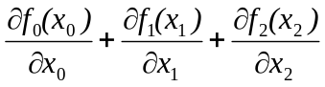 = q for all 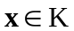
The application of this general form to the problem of heat transfer in a 2-dimensional body results in (see for example: [1]):
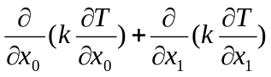 = 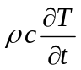 for all
with: k = thermal conductivity
c = specific heat
ρ = density of the body
the boundary conditions are:
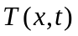 = f(x, t) | on that part of the boundary where the temperature is specified
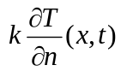 = g(x, t) | on that part of the boundary where the temperature stream in  the direction of the outward normal vector is specified

where f(x,t) and g(x,t) are known functions that must be predefined.
In case, the problem to be solved is an initial value problem, additional initial conditions are given by:
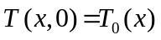 for all
Applying the Finite Element Method on the spatial aspects of the problem, the partial differential equation can be converted to a set of ordinary differential equations of the form:
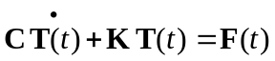 and 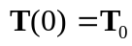 (1)
where: 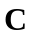is the specific heat matrix
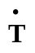is the vector of temperature gradients
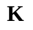is the thermal conductivity matrix
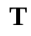 is the temperature vector
is forcing function vector of induced temperatures
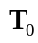 is the initial temperature vector at time=0

Eigenfunction Solution
Substitution of the eigenfunction solution for the homogeneous case with
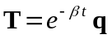 and 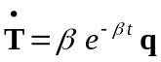
results in: 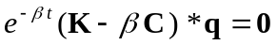
where: β is one of n-eigenvalues for which this equation is true
q is the corresponding eigenvector
The solution for eigenvalues is given by:
det 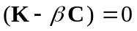
This, however, is only a viable solution for small values of n.
The general solution of this eigenproblem yields a number of n-eigenpairs 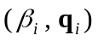) with an eigenvalue and eigenvector each. The eigenvectors are both 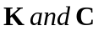orthogonal.
The solution for all eigenpairs can be written as:
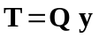
with: 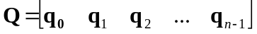
and: , the modal participation
Substituting this into equation (1), and premultiplying by 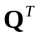 results in:
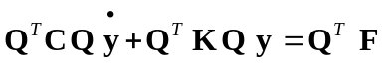
since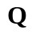 is both orthogonal, this will result in the following set of equations:
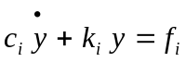 with: 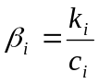
where: 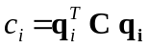, 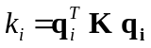, 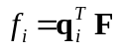
Time Integration Solution
Solving equations of this type in time, i.e. at a set of discrete times t_{k} , can be accomplished by a time stepping scheme such as (Ralston)
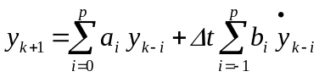 + R (truncation error)
For p>0 this is called a multi-step method and for p= 0, it is called a one-step method:
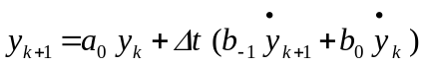
Application of time stepping schemes in the solution of initial value problems are approximations to the exact solution and must therefore address the issues of
consistency, stability and order of method
Consistency and stability are both necessary and sufficient conditions for a method to be convergent, i.e. for the discrete solution to converge to the solution as the time step approaches zero (Δt → 0).
These conditions result in the requirements that:
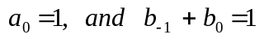
which can be reduced to a single variable parameter α that can be used for controlling stability resulting in the following equation that is consistent for all α:
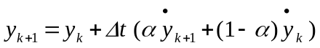
Stability considerations are controlled by the parameter α and lead to the following definition of the critical time step Δt_{cr}:
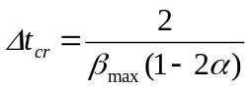
where β_{max} is the largest eigenvalue of problem to be solved.
The order of the method can be shown to be of first order unless α=½ when it becomes second order. This gives an indication of the rate of convergence as the time step approaches zero (Δt → 0).
For α=0, the method is called explicit method as the Right-Hand-Side only contains information at the current time step k. The critical time step is:
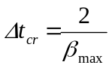
For nonzero values of α, the method is called implicit method as the Right-Hand-Side also contains information at the next time step (k+1).
For (0 ≤ α < ½) the method is called conditionally stable with Δt ≤ Δt_{cr}. For (½ ≤ α ≤ 1) the method is called unconditionally stable and any time step can be used with regard to stability but must be chosen sufficiently small for accuracy.
Generalization of this method to multi-degree-of-freedom systems in heat transfer leads to:
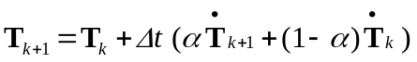
or 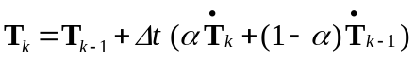
The solution algorithm can either be defined in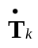 as the primary dependent variables or in 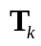. Using for these purposes has the advantage of being able to consider all values of α and Δt.
Substitution into equation (1) 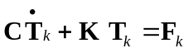 results in:
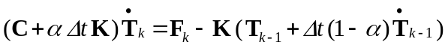
The solution algorithm is defined by the following steps:
at time =0: calculate initial temperature gradients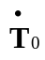
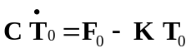
evaluate constant coefficient matrix 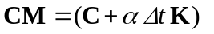
decompose constant coefficient matrix only once
for k=1 and | k < timeSteps
for k=1 and | time = time+Δt
for k=1 and | calculate temperature gradients at restrained nodes  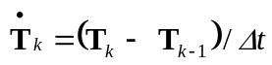
for k=1 and | calculate 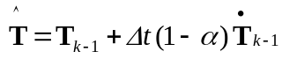
for k=1 and | modification of RHS: 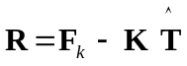
for k=1 and | backsubstitution of coefficient matrix with new RHS 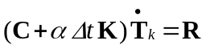, solve for temperature gradient
for k=1 and | compute temperature at next time step 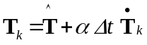

It should be noted that in case α=0: 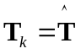. If 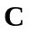 is diagonal, no equations need to be solved.

Example: Two Degree-of-Freedom System
Consider the following two degree-of-freedom problem:
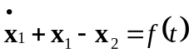
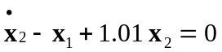
In matrix formulation:
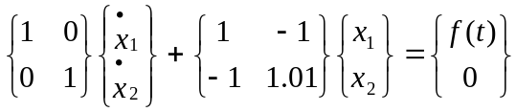

Compute the eigenvalues.
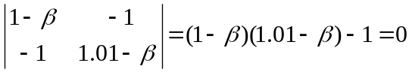

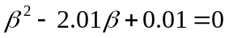
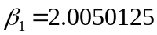
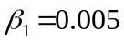

Write a program to solve this system by one of the algorithms discussed. Solve for the two load cases

Problem 1: 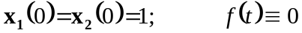
Problem 2:
for 0 ≤ t ≤ 400.

For each problem consider the following α and Δt values:
- α = 0; Δt for stability; Δt = 2
- α = ½ Δt = 5, 10, 20, 40
- α = ⅔ Δt = 5, 10, 20, 40
- α = 1 Δt = 5, 10, 20, 40

Dynamic Motion Analysis

problem: 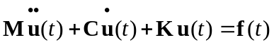 and 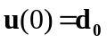, 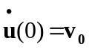
where: 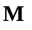 is the structural mass matrix
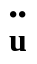is the acceleration vector
is the structural damping matrix
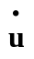is the velocity vector
is the structural stiffness matrix
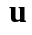 is the displacement vector
is forcing function vector of predefined deformations
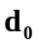and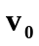are the initial deformation and velocity vectors

Eigenfunction Solution
Substitution of the eigenfunction solution for the homogeneous case with
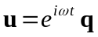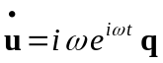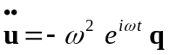
results in: 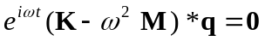
where: ω is one of n-eigenvalues for which this equation is true
q is the corresponding eigenvector
The solution for eigenvalues is given by:
det 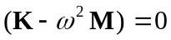
This, however, is only a viable solution for small values of n.
The general solution of this eigenproblem yields a number of n-eigenpairs 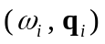) with an eigenvalue and eigenvector each. The eigenvectors are both 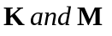orthogonal.
The solution for all eigenpairs can be written as:
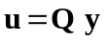
with: matrix of eigenvectors for free vibration,
undamped set of equations
and: , vector of modal participations

Substituting this into equation (1), and premultiplying by results in:
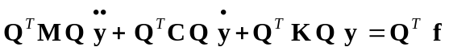
is both orthogonal. Q, however, is not generally C orthogonal. It will only be C orthogonal if damping is assumed to be either mass or stiffness proportional modal damping. This will result in the following equations for each mode:
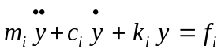 with: 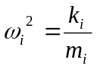
frequency of each modal response
where: 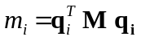
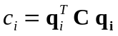
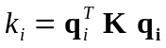
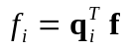

Often, these equations are written in the form:
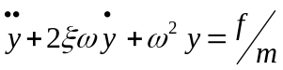 with: 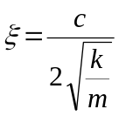
initial conditions are defined by:
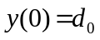 and 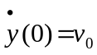
A distinction is made between
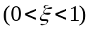 underdamped systems
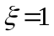 critical damping
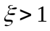 overdamped systems

Time Integration Solution
Various numerical methods were developed for Numerical Time Integration Methods in Structural Dynamics. Reference [3] presents an overview over the design and evaluation of these methods.
- Newmark’s method [4]:
solve: 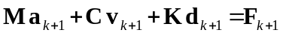
Newmark’s method is defined by the following formulas:
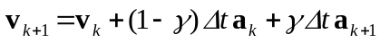
The algorithm can be implemented in terms of the unknown variables for 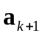, 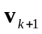 or 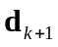. Using for these purposes simply requires substitution of Newmark’s formulas into the governing equations resulting in:
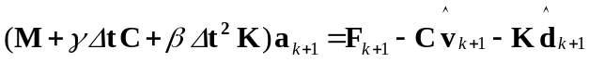
where: 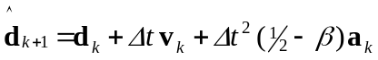
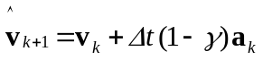 are called the predictors
and: 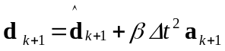
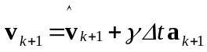 are called the correctors
The method is consistent for all values of and . It is unconditionally stable for 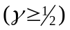 and 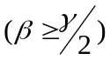.
It is conditionally stable for and 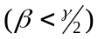. The critical time step is:
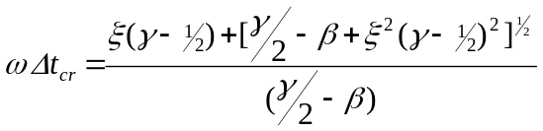
- Wilson’s Θ-method [5]:
Wilson suggested in 1973 a solution approach as a special case of equilibrium collocation. The general family of equilibrium collocation methods is defined by two parameters 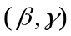 and the time step 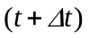 where equilibrium is satisfied. Wilson suggested equilibrium to be satisfied a time step of 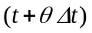 or 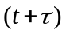 where 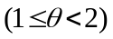.
This approach results in the following modifications to Newmark’s scheme:
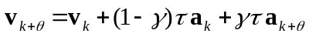
The algorithm will again be implemented in terms of the unknown variables for 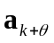. This simply requires substitution of the above formulas into the governing equations resulting in:
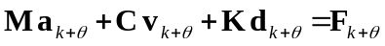
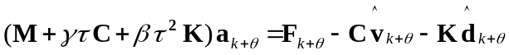 with: 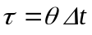
where: 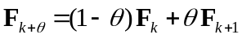 collocation of force
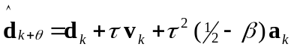
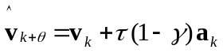
the system is solved for and from collocation of acceleration 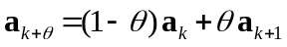we get
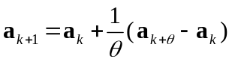
with this, Newmark’s algorithm can proceed as defined above
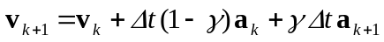
The method is generally “started” by determining 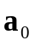from the initial conditions which is not consistent with the general approach (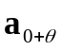). This effect is documented in the literature and may lead to “overshoot” in early parts of an analysis.
For values of 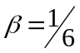 and 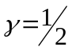 the method is referred to as Wilson’s Θ-method. The value of 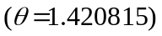 is recommended for this method with the additional requirement for 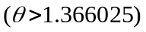.
- Taylor’s α-method [6]:
It is well documented in the literature that solution algorithms for time integration methods may also induce “algorithmic damping” into the system which is not part of the physical problem. In an attempt to improve the algorithmic damping of Newmark’s method, Taylor suggested in 1977 a modification of Newmark’s method which is referred to in the literature as the α-method.
In this method equilibrium is modified by including some stiffness proportional damping into the equilibrium equations:
The algorithm will again be implemented in terms of the unknown variables for . This simply requires substitution of the above formulas into the governing equations resulting in:
where: 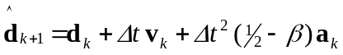
and:
A one-parameter model can be defined by constraining two parameters comparable to Wilson’s Θ-method. Taylor’s α-method is defined by
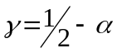 and 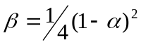
with: 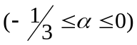
A discussion on consistency, stability and accuracy can be found in [3]. From this results:
- the minimum order of accuracy for all 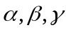 and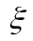 (real damping) is one.
- if 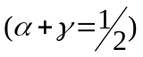 and either 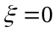 or 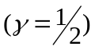 the method is second order accurate
- if , and 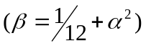 the method is third order accurate
- the methods are unconditionally stable for 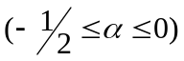, 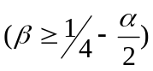 and
Implementation
All three methods may be combined into a single algorithm:
with: 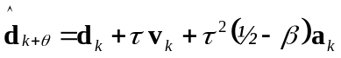
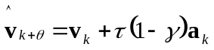

and:

In Newmark’s and Taylor’s methods backsubstitution of the equation will yield the acceleration at the next time step 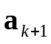 and the predictors 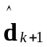 and 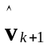 can be used to compute the displacement 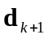 and velocity 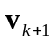 at the next time step. In Wilson’s method this is not possible as backsubstitution of the equation will yield the acceleration 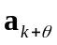at time step (k+θ) and the predictors 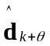and 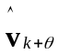 are also evaluated at time step (k+θ). Therefore, acceleration, displacement and velocity must be recomputed separately.

Integration parameters are set depending on the method chosen:
Newmark’s method: 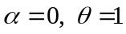 and 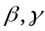will have to be defined
Wilson’s Θ-method 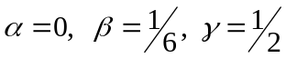 and 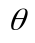 will have to be defined
Taylor’s α-method 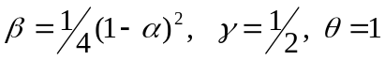 and 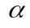will have to be defined
The solution algorithm is defined by the following steps:
at time step k=0: 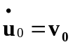 and 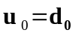 are set to initial conditions
calculate initial accelerations 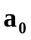 by solving 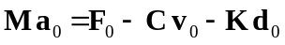
compute and decompose constant coefficient matrix
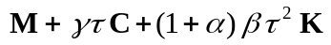 only once
for k ≤ k_{max}
for k ≤ k_{max} | k = k+1, time = time+dt
for k ≤ k_{max} | calculate predictors  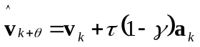
for k ≤ k_{max} | calculate new RHS
for k ≤ k_{max} | backsubstitution of coefficient matrix with new RHS  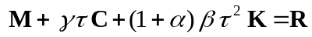 for acceleration
for k ≤ k_{max} | compute accelerations, displacements and velocities at next time step  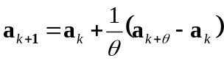

Example 1: Two Degree-of-Freedom System
Consider the following two degree-of-freedom problem:
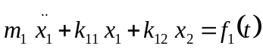
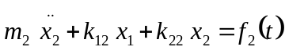

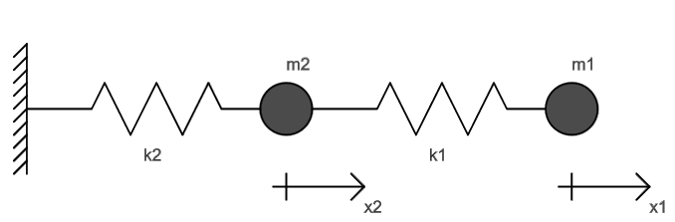
where: k₁ = 1.; k₂ = 0.01; m₁ = 1.; m₂ = 1.;

- Write a program to solve this system using the Newmark algorithm. Solve for the following initial value problem:
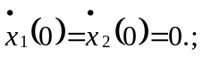

- Write a program to solve this system using the 3 algorithms discussed in class. Solve for the following initial value problem:
and solve for the following forcing function problem:

for 0 ≤ t ≤ 400.
For each problem consider the following α and Δt values:
- α = 0; Δt for stability; Δt = 2
- α = ½ Δt = 5, 10, 20, 40
- α = ⅔ Δt = 5, 10, 20, 40
- α = 1 Δt = 5, 10, 20, 40

Example 2: Two Degree-of-Freedom System with Ground Acceleration
Consider the following two degree-of-freedom problem:
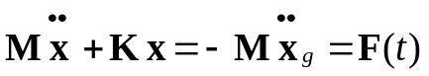

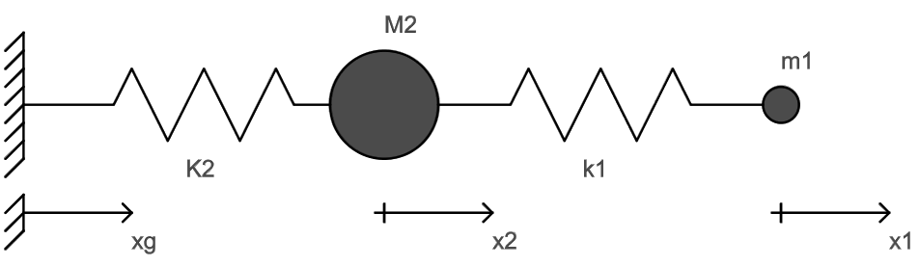
where: k₁ = 0.01; K₂ = 1.; m₁ =0.01; M₂=1.;
and x₁, x₂ are defined relative to x_{g}

with the following definition for the ground acceleration:
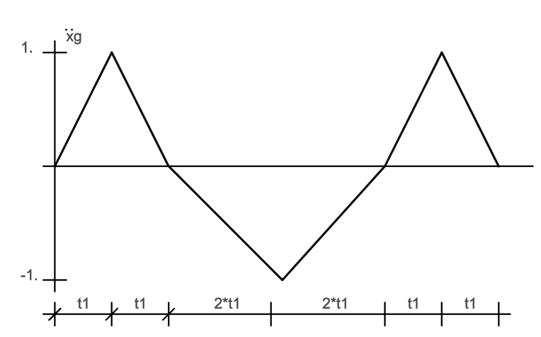

where: t₁ = 0.8 and 0 ≤ t ≤ 125.
solve the system for the following integration parameters:
- Newmark: β = 0.25; γ=0.5 Δt = 0.4
- Wilson-θ: θ = 1.420815 Δt = 0.4
- α-method: α = -0.1 Δt = 0.4

